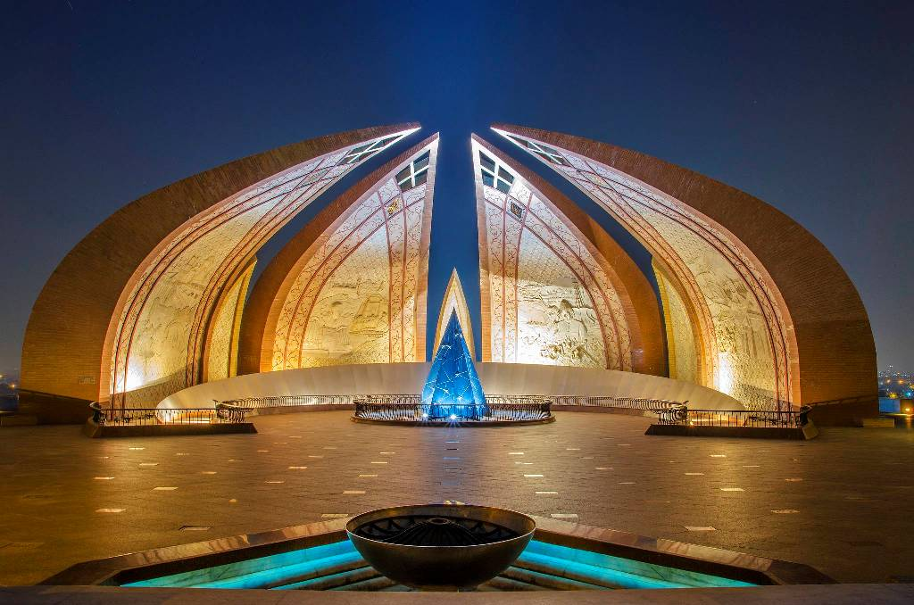

**Pakistan Monument**

Petal-shaped symbol of unity houses a captivating wax museum journey through Pakistan's history.

**History**

Established in 2010, the Pakistan Monument Museum narrates the story of sacrifice and unity from ancient civilizations to modern achievements.